PYTHON DEVELOPER INTERNSHIP PROGRAM

Hasnain Karimain Educational Academy
Software House & Training Center

Registered with SECP & PSEB (Ministry of IT, Government of Pakistan)

Shift: 1st Tasks / Projects Assigned Days: Monday to Wednesday

Task 1: Advanced CLI Contact Management System with Search & Filters

●◉’ Objective

Develop a professional Command-Line Contact Management System that allows users to store, manage, search, and filter contacts efficiently. The system should simulate a real-world mini-CRM (Customer Relationship Management tool).

Task Description
Create a Python-based CLI application where users can:

- Add new contacts
- View all contacts
- Search contacts by name, phone, or email
- Apply filters (e.g., by city or company)
- Update existing contact details
- Delete contacts
- Save and load data from a file (JSON/CSV)

The system should be interactive, user-friendly, and modular.

•HO Functional Requirements

Contact Fields:
Each contact must include:

- Full Name
- Phone Number
- Email Address
- City
- Company

Core Features:

Add Contact
    - Validate input (no empty fields, valid email/phone)

View Contacts
    - Display in formatted table style

Search Contacts
    - By Name (partial match)
    - By Phone
    - By Email

Filter Contacts
    - By City
    - By Company

Update Contact
    - Edit specific fields

Delete Contact
    - Delete by ID or Name

Data Persistence
    - Save contacts in JSON or CSV
    - Load data automatically on program start

Advanced Requirements (Must Have)
- Use functions for each feature
- Implement menu-driven CLI interface
- Use exception handling for errors
- Implement search optimization (case-insensitive)
- Add unique ID for each contact
- Use modular code structure (separate functions/files optional)

Bonus Features (Optional but Recommended)
- Export contacts to CSV
- Import contacts from file
- Add favorite/starred contacts
- Pagination for large data
- Sorting (A-Z, Recently Added)

Deliverables
Intern must submit:

- ✅ Source Code (ZIP file)
- ✅ GitHub Repository
- ✅ README.md (features + how to run)
- ✅ Sample Data File (JSON/CSV)
- ✅ Demo Video (1–2 minutes)

★ ● z
Deadline
24 Hours

Project Report

Objective
The objective of this project is to develop a Command-Line Contact Management System (CRM-like application) using Python. The system allows users to efficiently store, manage, search, filter, update, and delete contact information with data persistence.

Project Description
This project is a menu-driven CLI application built in Python. It simulates a basic Customer Relationship Management (CRM) system where users can manage contacts in a structured and efficient way.
All contact data is stored in a JSON file, ensuring that data is saved permanently even after the program closes.

CODE:
Main.py
import json import os import re
from datetime import datetime FILE_NAME = "contacts.json"

# ========================= # LOAD DATA
# =========================
def load_contacts():
if os.path.exists(FILE_NAME): try:
with open(FILE_NAME, "r") as file: return json.load(file)
except:
return [] return []

# ========================= # SAVE DATA

# =========================
def save_contacts(contacts):
with open(FILE_NAME, "w") as file: json.dump(contacts, file, indent=4)

# ========================= # ID GENERATOR
# =========================
def generate_id(contacts): if not contacts:
return 1
return max(c["id"] for c in contacts) + 1

# ========================= # VALIDATIONS
# =========================
def validate_email(email):
pattern = r'^[\w\.-]+@[\w\.-]+\.\w+$' return re.match(pattern, email)

def validate_phone(phone): pattern = r'^\+?\d{10,15}$'
return re.match(pattern, phone)

# ========================= # ADD CONTACT
# =========================
def add_contact(contacts): print("\n=== ADD CONTACT ===")

name = input("Name: ").strip() phone = input("Phone: ").strip() email = input("Email: ").strip() city = input("City: ").strip()
company = input("Company: ").strip()

if not all([name, phone, email, city, company]): print("❌ All fields are required.")
return

if not validate_email(email): print("❌ Invalid email.")

return

if not validate_phone(phone): print("❌ Invalid phone number.") return

contact = {
"id": generate_id(contacts), "name": name,
"phone": phone, "email": email, "city": city, "company": company, "favorite": False,
"created_at": str(datetime.now())
}

contacts.append(contact) save_contacts(contacts)

print("✅ Contact added successfully!")

# =========================
# VIEW CONTACTS (FIXED OUTPUT) # =========================
def view_contacts(contacts): if not contacts:
print("\n⚠ No contacts found.")
return

print("\n================ CONTACT LIST ================\n")

header = f"{'ID':<5} {'Name':<20} {'Phone':<15} {'Email':<25} {'City':<15}
{'Company':<15}" print(header)
print("-" * len(header))

for c in contacts: print(
f"{c['id']:<5} "
f"{c['name']:<20} "
f"{c['phone']:<15} "
f"{c['email']:<25} "
f"{c['city']:<15} "

f"{c['company']:<15}"
)

print("\n==============================================\n")

# ========================= # SEARCH CONTACTS
# =========================
def search_contacts(contacts):
keyword = input("\nSearch (name/phone/email): ").lower()

result = [
c for c in contacts
if keyword in c["name"].lower() or keyword in c["phone"]
or keyword in c["email"].lower()
]

if not result:
print("❌ No match found.") return

view_contacts(result)

# ========================= # FILTER CONTACTS
# =========================
def filter_contacts(contacts): print("\n1. Filter by City") print("2. Filter by Company")

choice = input("Choose: ")

if choice == "1":
city = input("Enter city: ").lower()
result = [c for c in contacts if c["city"].lower() == city]

elif choice == "2":
company = input("Enter company: ").lower()
result = [c for c in contacts if c["company"].lower() == company]

else:
print("❌ Invalid choice.")

return

if not result:
print("❌ No contacts found.") return

view_contacts(result)

# ========================= # UPDATE CONTACT
# =========================
def update_contact(contacts): try:
cid = int(input("\nEnter Contact ID: ")) except:
print("❌ Invalid ID")
return

for c in contacts:
if c["id"] == cid:

print("Leave blank to keep old value\n")

name = input(f"Name ({c['name']}): ").strip()
phone = input(f"Phone ({c['phone']}): ").strip()
email = input(f"Email ({c['email']}): ").strip()
city = input(f"City ({c['city']}): ").strip()
company = input(f"Company ({c['company']}): ").strip()

if name:
c["name"] = name if phone:
if validate_phone(phone): c["phone"] = phone
if email:
if validate_email(email): c["email"] = email
if city:
c["city"] = city if company:
c["company"] = company

save_contacts(contacts) print("✅ Updated successfully!")

return

print("❌ Contact not found")

# ========================= # DELETE CONTACT
# =========================
def delete_contact(contacts): try:
cid = int(input("\nEnter Contact ID: ")) except:
print("❌ Invalid ID")
return

for c in contacts:
if c["id"] == cid: contacts.remove(c) save_contacts(contacts)
print("✅ Deleted successfully!")
return

print("❌ Not found")

# ========================= # SORT CONTACTS
# =========================
def sort_contacts(contacts): contacts.sort(key=lambda x: x["name"].lower()) print("✅ Sorted A-Z") view_contacts(contacts)

# ========================= # FAVORITE CONTACT
# =========================
def favorite_contact(contacts): try:
cid = int(input("\nEnter Contact ID: ")) except:
print("❌ Invalid ID")
return

for c in contacts:

if c["id"] == cid: c["favorite"] = True save_contacts(contacts)
print("⭐ Marked as favorite")
return

print("❌ Not found")

# ========================= # MAIN MENU
# =========================
def main():
contacts = load_contacts()

while True:
print("\n===== CONTACT MANAGEMENT SYSTEM =====")
print("1. Add Contact") print("2. View Contacts") print("3. Search Contacts") print("4. Filter Contacts") print("5. Update Contact") print("6. Delete Contact") print("7. Sort Contacts") print("8. Favorite Contact") print("9. Exit")

choice = input("Enter choice: ")

if choice == "1": add_contact(contacts)
elif choice == "2": view_contacts(contacts)
elif choice == "3": search_contacts(contacts)
elif choice == "4": filter_contacts(contacts)
elif choice == "5": update_contact(contacts)
elif choice == "6": delete_contact(contacts)
elif choice == "7": sort_contacts(contacts)
elif choice == "8": favorite_contact(contacts)

elif choice == "9": print("👋 Exiting...") break
else:
print("❌ Invalid choice")

# ========================= # RUN PROGRAM
# =========================
if name == " main ": main()

Contact.json
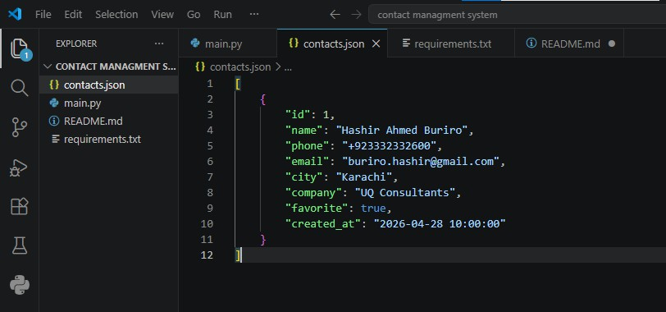

OUTPUT:
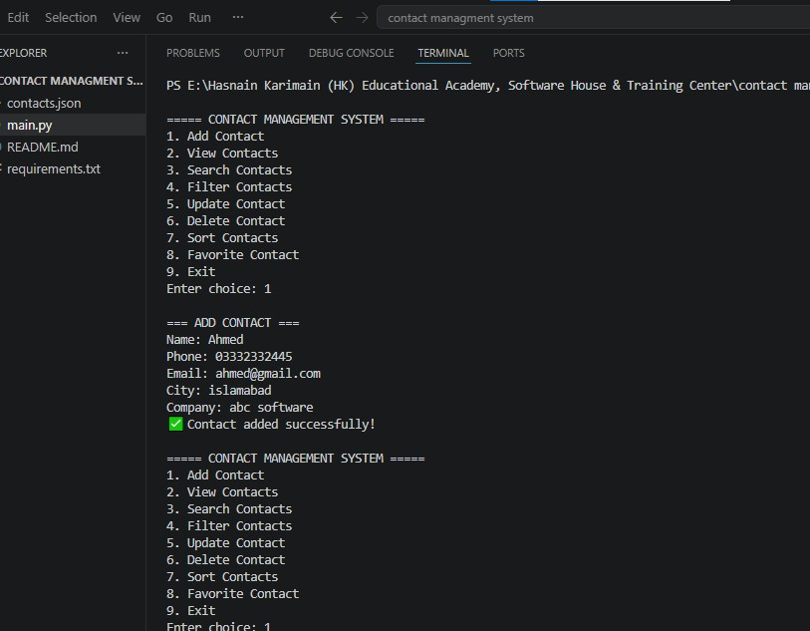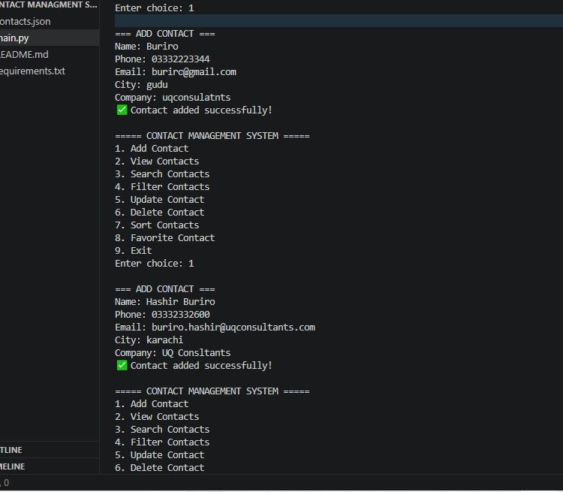

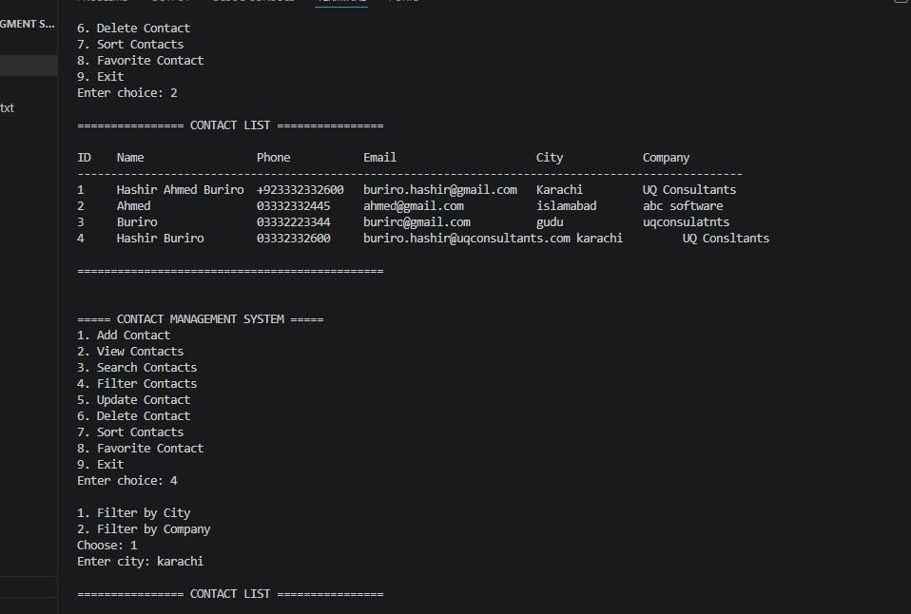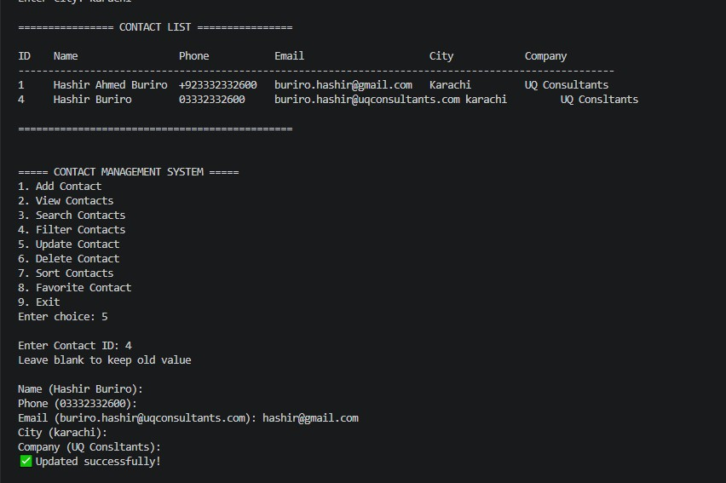

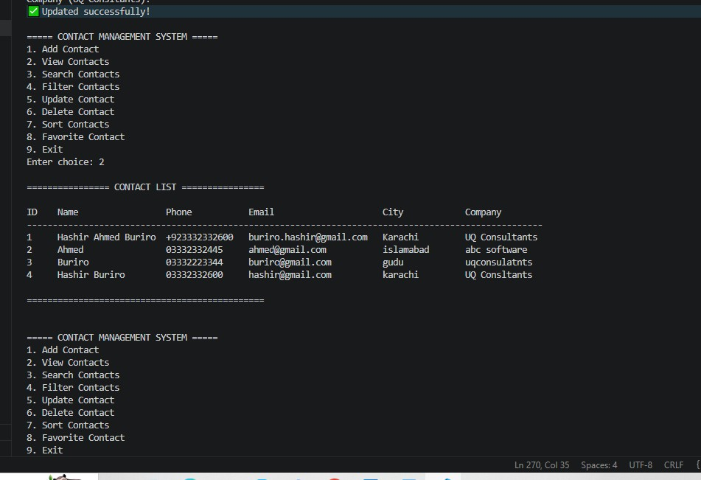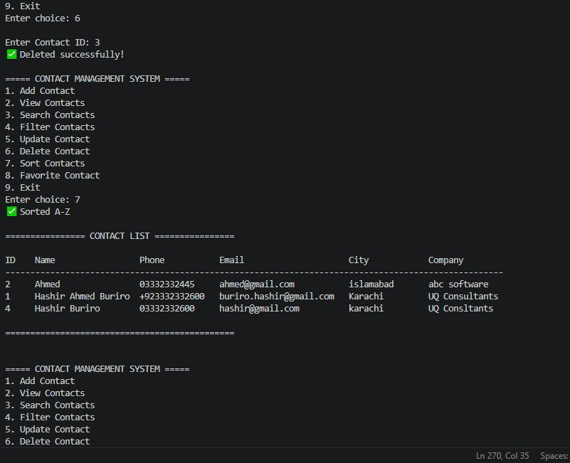

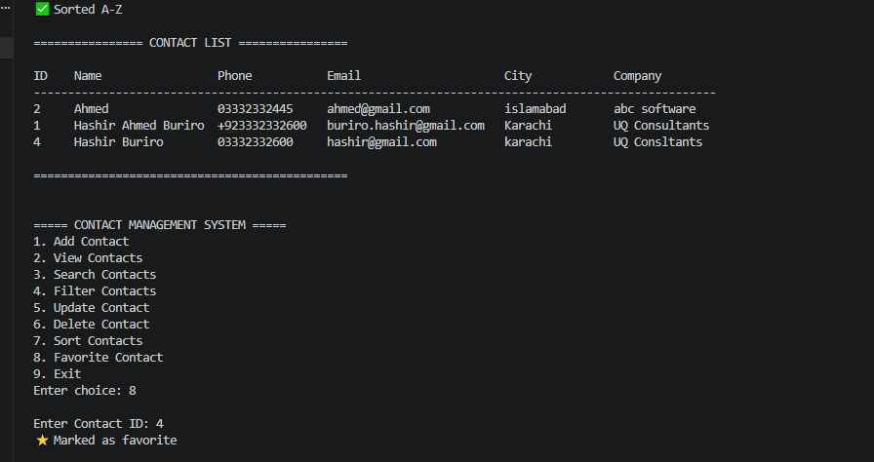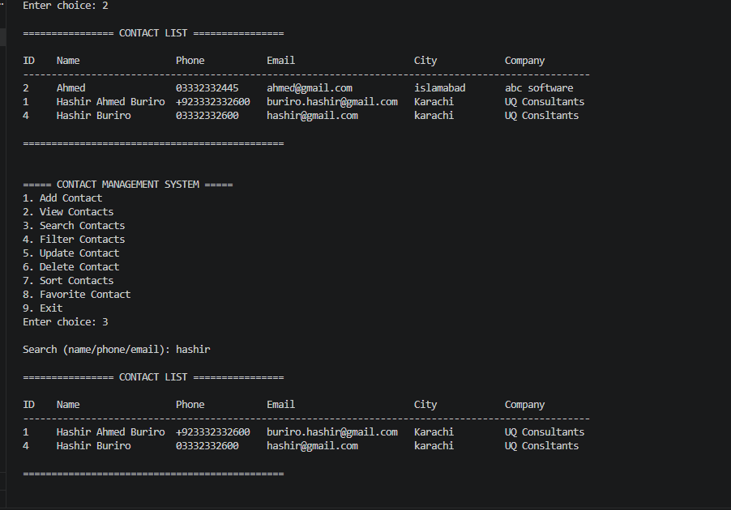

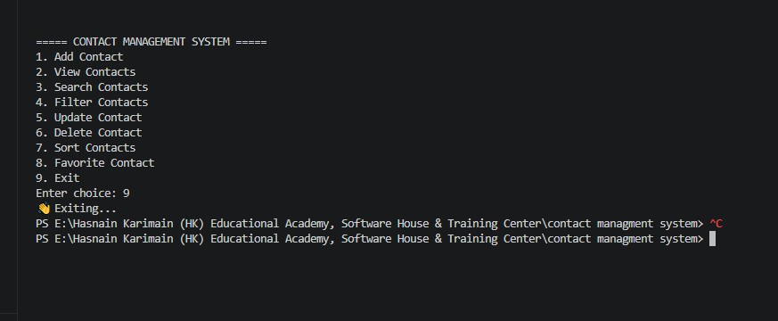

Data Save Successfully in JSON File Updated Data:
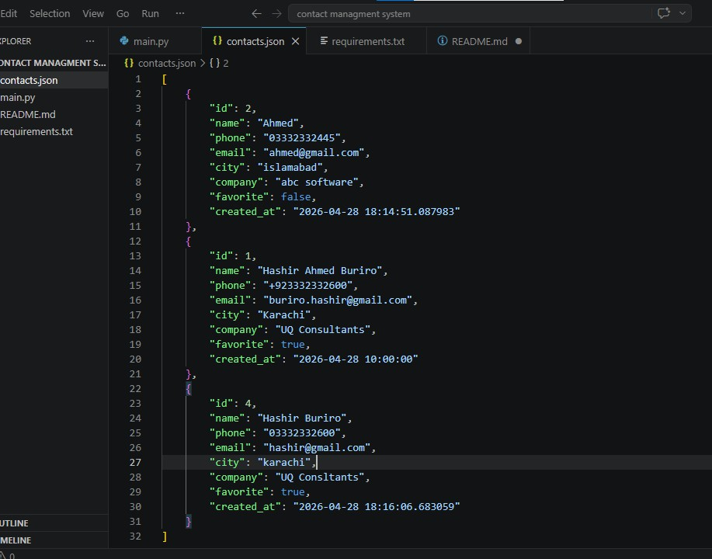

Result
The developed Contact Management System was fully tested and performed as expected. All functional requirements were successfully implemented, including contact creation, advanced search, filtering, updates, deletion, and data persistence using JSON file handling. The system provides a smooth and user-friendly CLI experience with proper validation and error handling. Overall, the project meets the internship requirements and demonstrates strong understanding of Python programming fundamentals and real-world application development.

Conclusion
This Contact Management System project provides a practical implementation of a mini-CRM built in Python. It focuses on real-world functionality such as contact storage, advanced searching, filtering, and data management using a JSON-based persistence system. The project demonstrates strong understanding of modular programming, file handling, input validation, and CLI-based user interaction. It serves as a solid foundation for building more advanced systems like database-driven CRM or GUI applications in the future.

🐍 Task 2: Multi-User Authentication System using JSON Storage
🎯 Objective
Develop a secure multi-user authentication system using Python that allows users to register, login, and manage their accounts using JSON-based data storage.
🛠 Task Description
Create a CLI-based Python application where multiple users can:
- Register a new account
- Login with credentials
- Store user data securely in a JSON file
- Validate user inputs and handle authentication properly
This system should simulate a basic real-world login/signup system.
⚙️ Functional Requirements
🔹 User Registration
- Input: Username, Email, Password
- Validate:
  - Unique username/email
  - Strong password rules
- Store data in JSON file
🔹 User Login
- Verify username/email + password
- Display success or error messages
🔹 Password Security
- Hash passwords before storing (use hashlib or similar)
- Do NOT store plain text passwords
🔹 Data Storage
- Use JSON file for storing users
- Load data on program start
- Update file after every change

🔹 Menu System
- Register
- Login
- Exit
💡 Advanced Requirements (Must Have)
- Password hashing (SHA-256 or better)
- Input validation & error handling
- Case-sensitive authentication
- Modular functions (separate logic)
- Prevent duplicate accounts
🌟 Bonus Features
- Password reset functionality
- Account deletion
- Login attempt limit (security)
- Email format validation using regex
- Role-based users (Admin/User)
📦 Deliverables
- ✅ Source Code (ZIP file)
- ✅ JSON Database File
- ✅ GitHub Repository
- ✅ README.md (features + how to run)
- ✅ Demo Video (1–2 minutes)
⏰ Deadline 24 Hours

Project Report:
Objective
The objective of this project is to develop a secure multi-user authentication system in Python that allows users to register, login, and manage their accounts using JSON-based data storage. The system ensures data security through password hashing, input validation, and duplicate account prevention, simulating a real-world login system.
Project Description
This is a CLI-based Python authentication system that securely manages multiple user accounts using JSON file storage.
It allows users to register and login with proper validation, including unique username/email checks and strong password rules. Passwords are stored securely using SHA-256 hashing instead of plain text.
The system loads user data from a JSON file at startup and updates it after every operation. It also includes basic security features like input validation, duplicate account prevention, and login verification through an interactive menu (Register, Login, Exit).
CODE:
Authenticate_system.py:
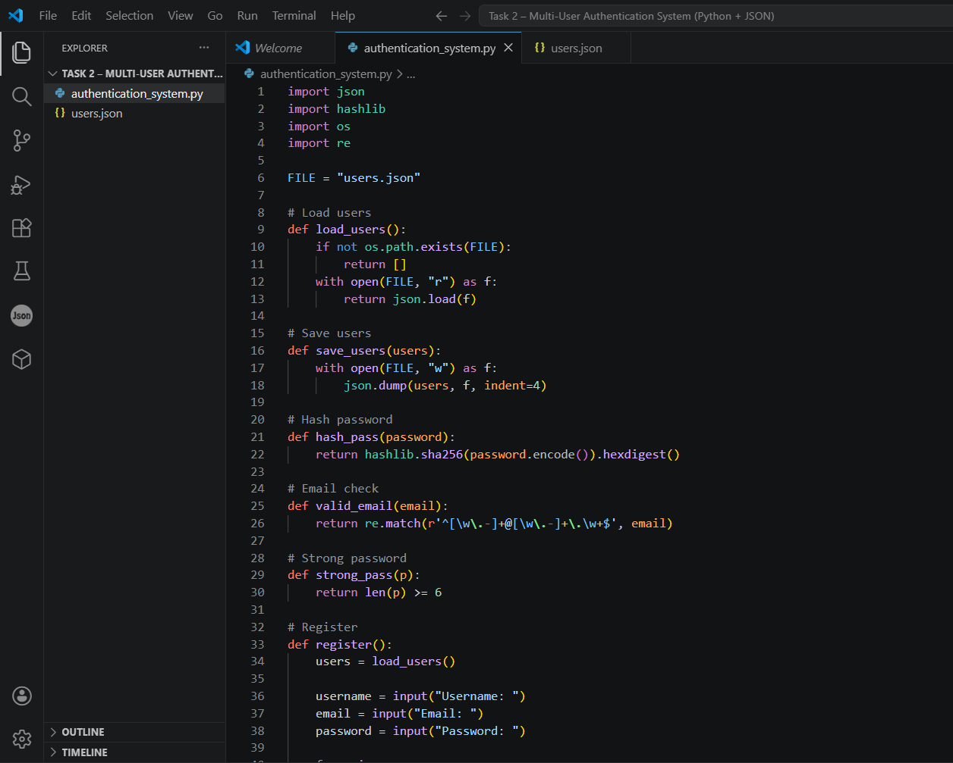
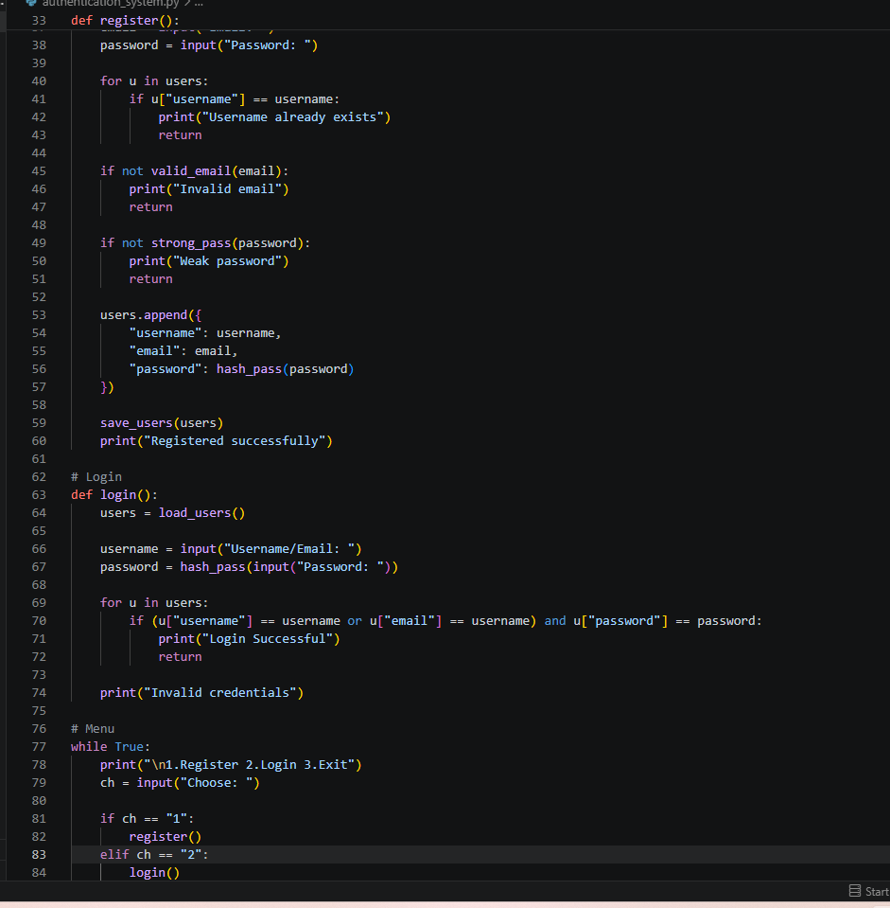
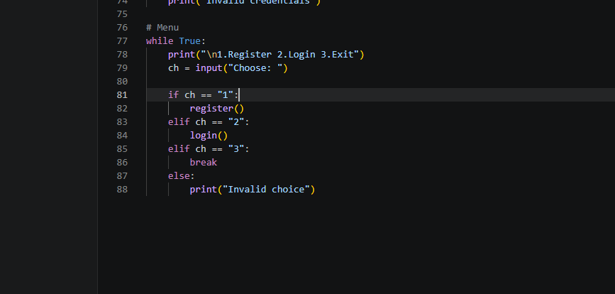

Output:
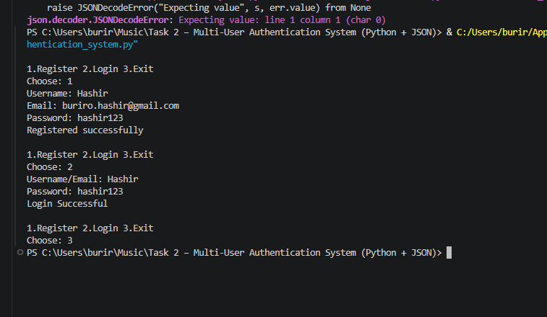
User.json
Data was automatically saved and updated in users.json
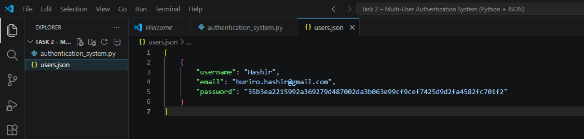

Result:
The Multi-User Authentication System was successfully implemented and tested in Python. The system allows users to register new accounts, securely login, and manage stored data using a JSON file.
During testing:
- User registration worked correctly with validation checks.
- Duplicate usernames and emails were successfully blocked.
- Passwords were stored in hashed (SHA-256) format, not plain text.
- Login functionality correctly verified credentials from the JSON file.
- Invalid login attempts were handled with proper error messages.
- Data was automatically saved and updated in users.json.
Overall, the system performed as expected and demonstrated a basic but secure authentication workflow similar to real-world applications.
Conclusion
This project helped in understanding the fundamentals of user authentication systems, file handling, and data security in Python. By implementing features like password hashing, input validation, and JSON-based storage, a simple yet secure login system was successfully developed.
It simulates real-world authentication logic used in web and software applications, improving skills in Python programming, security practices, and data management.

🐍 Task 3: Custom Data Encryption & Decryption Tool
🎯 Objective
Develop a Python-based tool that can securely encrypt and decrypt data using custom logic and basic cryptographic techniques. This simulates real-world data protection systems.
🛠 Task Description
Create a CLI-based application where users can:
- Enter text data
- Encrypt the data using a custom algorithm
- Decrypt the data back to original form
- Save encrypted data to a file
- Load and decrypt stored data
The tool should ensure data security and proper transformation logic.
⚙️ Functional Requirements
🔹 Encryption
- Input: Plain text
- Apply custom encryption logic (e.g., shifting, substitution, encoding)
- Output: Encrypted text
🔹 Decryption
- Input: Encrypted text
- Reverse the encryption logic
- Output: Original text
🔹 File Handling
- Save encrypted data to a file (TXT/JSON)
- Load encrypted data from file and decrypt
🔹 User Interface
- Menu options:
  - Encrypt Data
  - Decrypt Data
  - Save Data

  - Load Data
  - Exit
💡 Advanced Requirements (Must Have)
- Use custom encryption algorithm (not just base64 only)
- Maintain reversible logic (encryption ↔ decryption)
- Implement error handling
- Use modular functions
- Ensure encryption is not easily readable
🌟 Bonus Features
- Add password/key-based encryption
- Use multiple encryption layers
- Time-stamp encrypted data
- Encrypt/decrypt files (not just text)
- GUI version (Tkinter)
📦 Deliverables
- ✅ Source Code (ZIP file)
- ✅ Sample Encrypted File
- ✅ GitHub Repository
- ✅ README.md (algorithm explanation + usage)
- ✅ Demo Video (1–2 minutes)
⏰ Deadline
24 Hours

Project Report
Objective
The objective of this project is to develop a Python-based encryption and decryption tool that securely transforms user data using a custom encryption algorithm, allowing safe storage and retrieval of information.
Project Description
This is a CLI-based Python application that allows users to encrypt and decrypt text data using a custom logic with a secret key. The encrypted data can also be saved and loaded from a file.
The system performs:
- Text encryption using character shifting + encoding
- Decryption to restore original text
- File handling using JSON/TXT storage
- Key-based security for encryption and decryption
It ensures data protection by making information unreadable without the correct key and provides a simple menu-based interface for users (Encrypt, Decrypt, Save, Load, Exit).
CODE:
Encryption_tool.py:
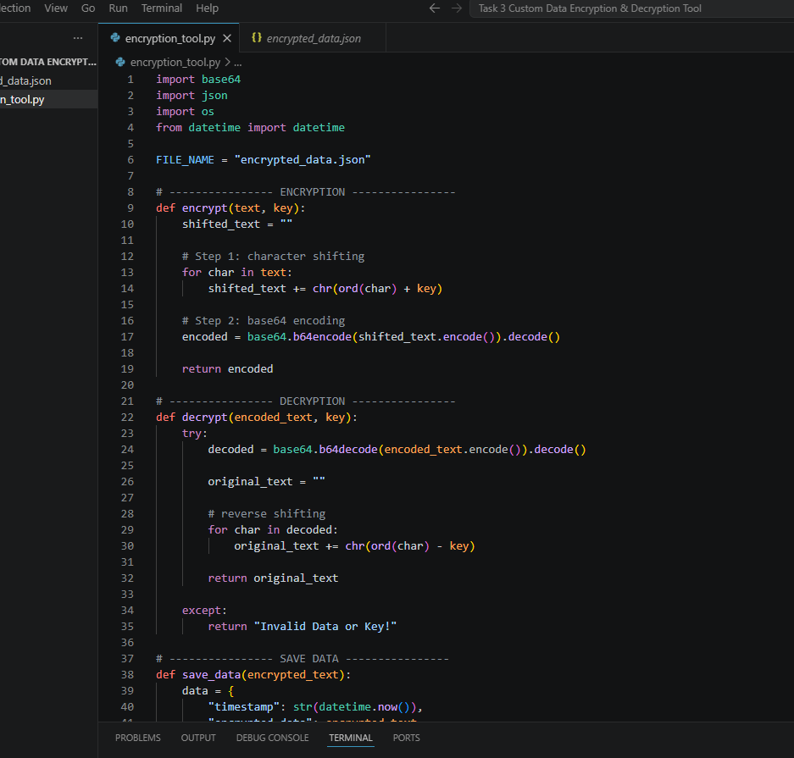
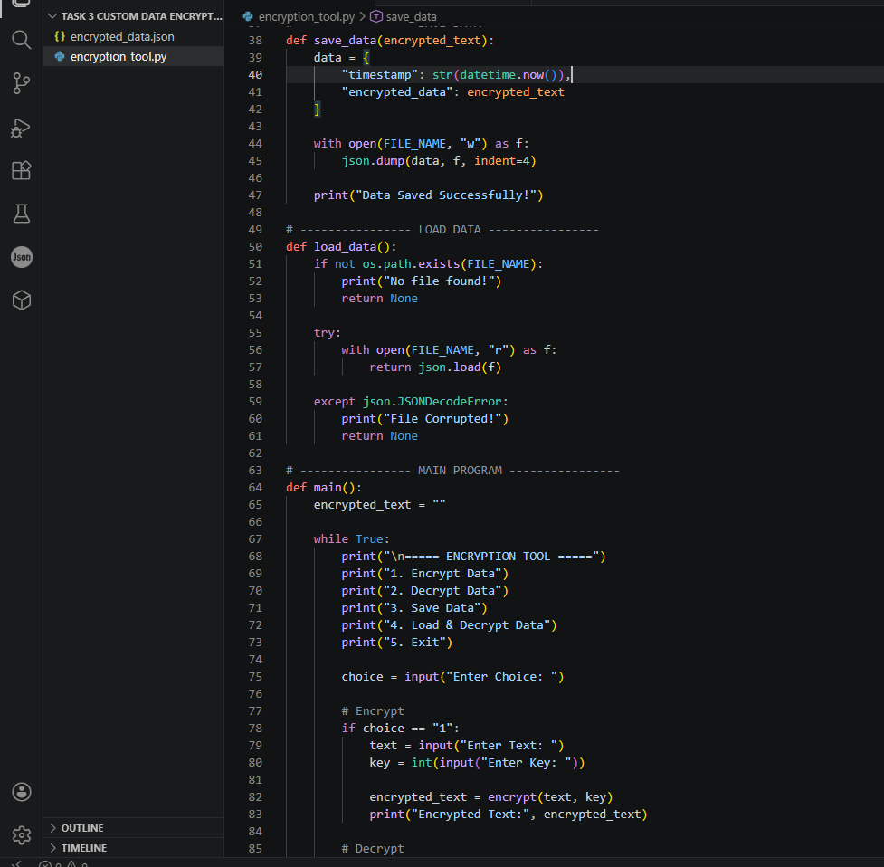
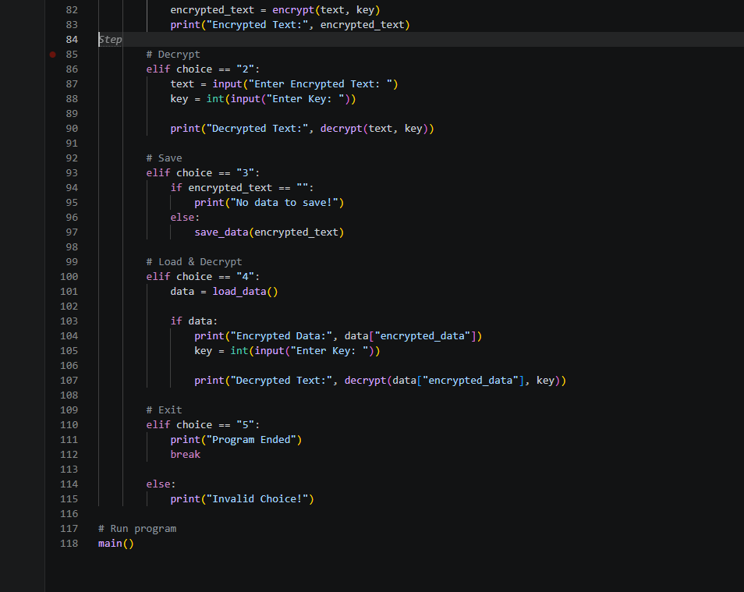

Output:
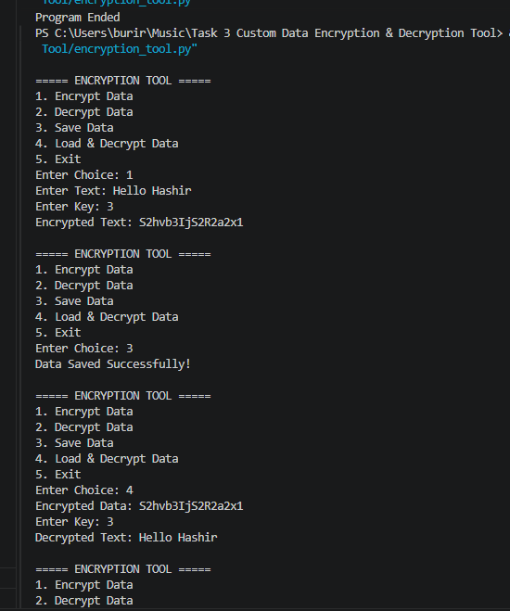
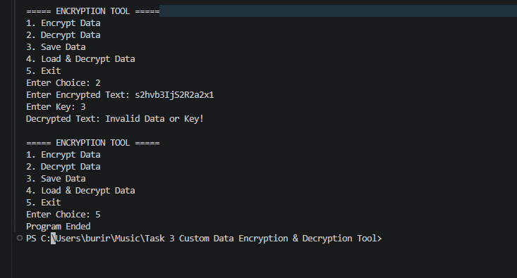

Encrypted_data.json:
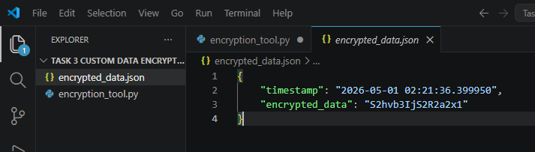
GUI Base:
Gui_encyption_data.py:
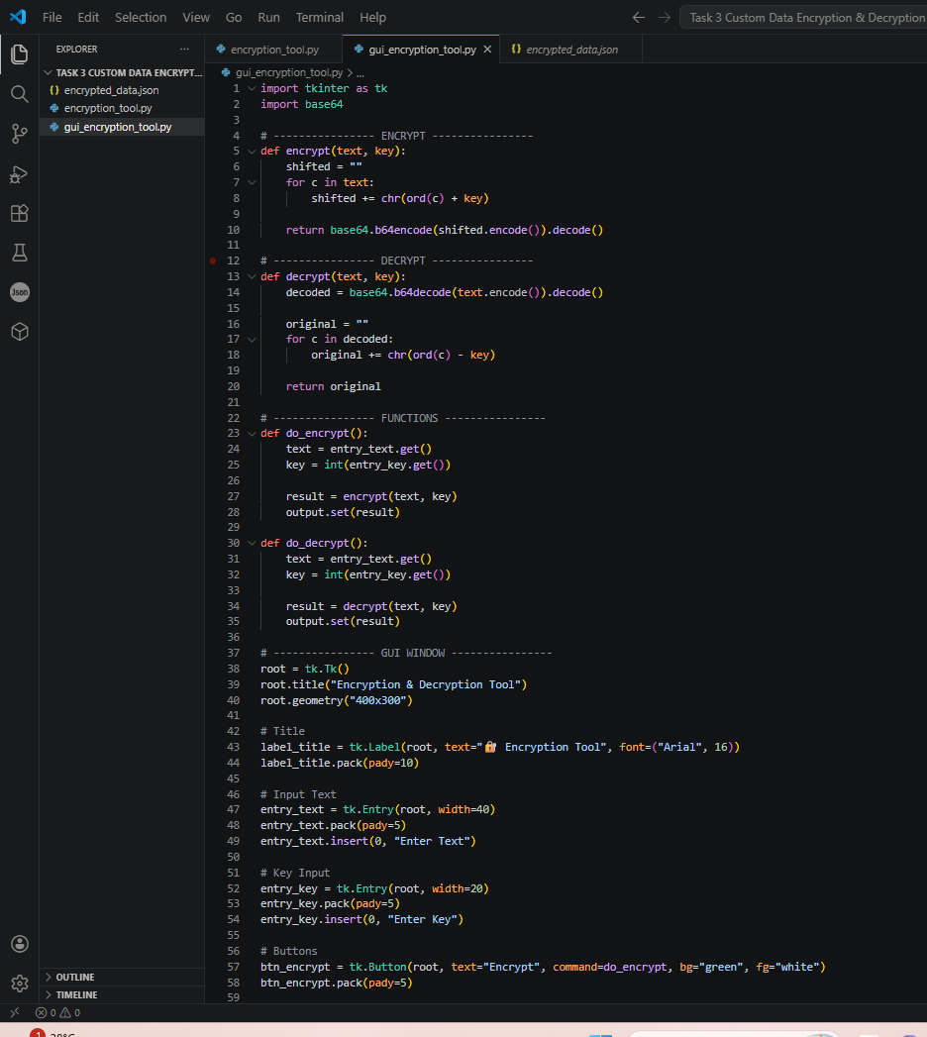
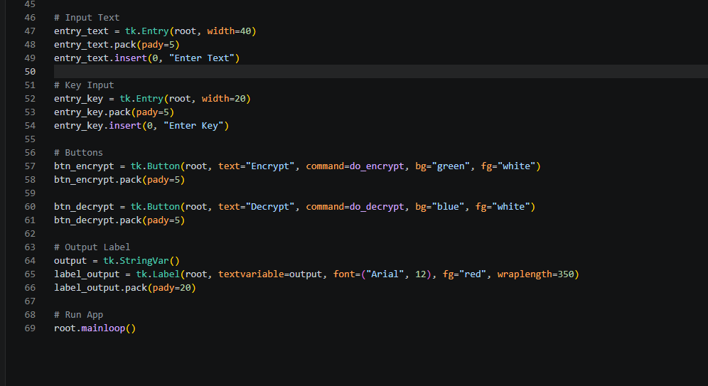
Output:
Encrypt:
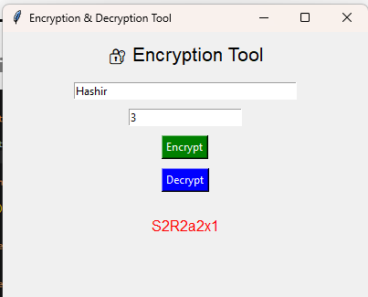
Decrypt:
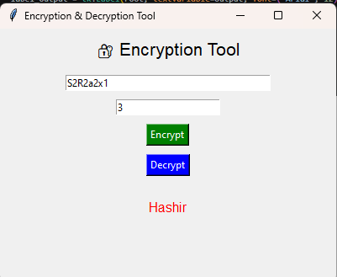

Result
The encryption tool was successfully tested and worked as expected.
- Plain text was correctly encrypted into unreadable encoded format.
- Decryption successfully restored the original text using the same key.
- Encrypted data was saved and retrieved from a file without data loss.
- Incorrect key usage resulted in failed decryption, ensuring security.
- File handling worked properly for storing and loading encrypted content.
Overall, the system demonstrated proper data transformation, security handling, and file management.
Conclusion:
This project helped in understanding the basics of cryptography, data security, and encryption techniques in Python. By implementing a custom encryption and decryption algorithm, it demonstrates how sensitive data can be protected and safely stored.
It also improved skills in string manipulation, encoding techniques, file handling, and modular programming, making it a simple but effective real-world security simulation tool.

